

Elementry Programming

Java Chapter 2



September 11, 2019

Thomas J. Short

Cis260-01

Checkpoints

**#2.3.1**  **(A.)** To allow a user to input a double value we borrow a scanner tool from the java library using (import java.until.Scanner). Then we must create a scanner object using (Scanner input = new Scanner(System.in)). Now we ask the user to enter a value with System.out.println(“Enter a value”). Assign the user variable with (double userVariable = input.nextDouble(); ).

**(B.)** If the user enters a value that is not a number, the program will not execute and crash. It actually takes you to line of code in blue jay editor window and it kicks you out of the terminal.

**#2.4.1** The keywords are class, public, and int. The legal identifiers are miles, a++, $4, apps, x, y, and radius. I believe Test would be a class name by convention because it starts with a capital letter.

**#2.7.1** The benefits of using a constant range from the ability to enter a value once throughout the entirety of the program. If a value needs to be changed it only needs to be changed in that one single location instead of several locations. This saves programmers time and can also improve the readability of our programs.

**#2.8.2** public class KilometersPerMile

{

Public static void main(String[] args)

{

double miles = 100;

final double kiloMetersPerMile = 1.609;

double kilometers = miles * kiloMetersPerMile;

System.out.println(kilometers);

}

}

Kilometers after step 4 is **160.9**

**#2.9.2** 56 % 6 = 2

78 % -4 = 2

-34 % 5 = -4

-34 % -5 = -4

5 % 1 = 0

1 % 5 = 1

**#2.9.3** (2 + 100 ) % 7 has a remainder of 4 which we know Thursday is the 4th day of the week.

**#2.9.5** System.out.println(2*(5/2+5/2)); = 8

System.out.println(2*5/2+2*5/2); = 10

System.out.println(2*(5/2)); = 4

System.out.println(2*5/2); = 5

**#2.9.8** System.out.println(Math.pow (m*r, 2));

**#2.10.2** Correct literals for floating-point numbers are 12.3e+2, 39f, and 4e-2.

**#2.11.1** **(a)** 4/3.0*(r+4) – 9*(a + b*c) + 3 + d * (2+a) / a + b * d

**(b)** System.out.println(5.5 *(Math.pow (r + 2.5, 2.5 + t )));

**#2.14.2** The following code will result:

int a = 6;

int b = a++;

System.out.println(a); 7

System.out.println(b); 6

a = 6;

b = ++a;

System.out.println(a); 7

System.out.println(b); 7

**#2.15.3**  F is 12.5

F is 12

**#2.18. 2 (a)** Integer overflow happens when you assign a value that is too large for a certain datatype. For example, if you try putting a long into a short or short into a byte.

**(b)** Integer overflow only applies to integers

2.3 Convert feet to meters

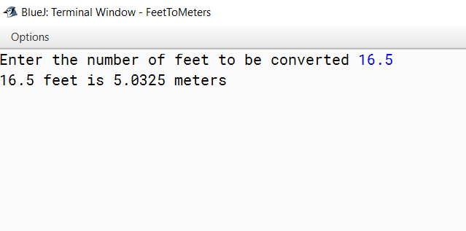

Programming Exercises

*2.5 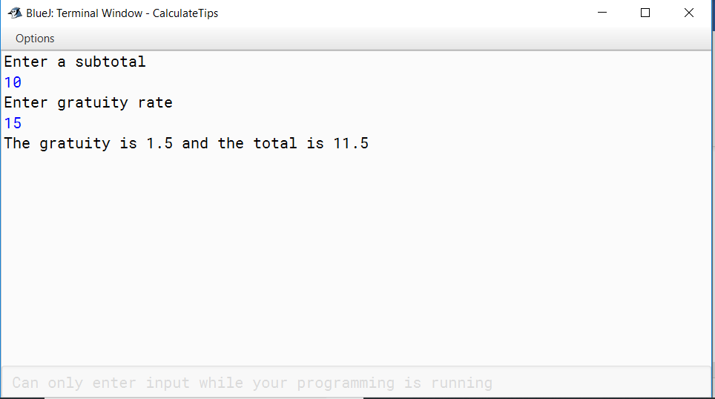Calculate Tips

**2.11 Population Project**

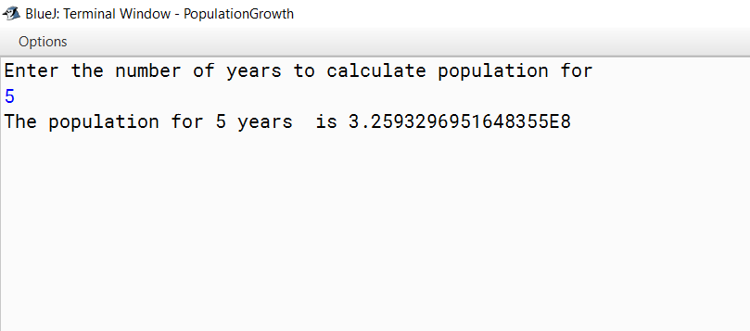

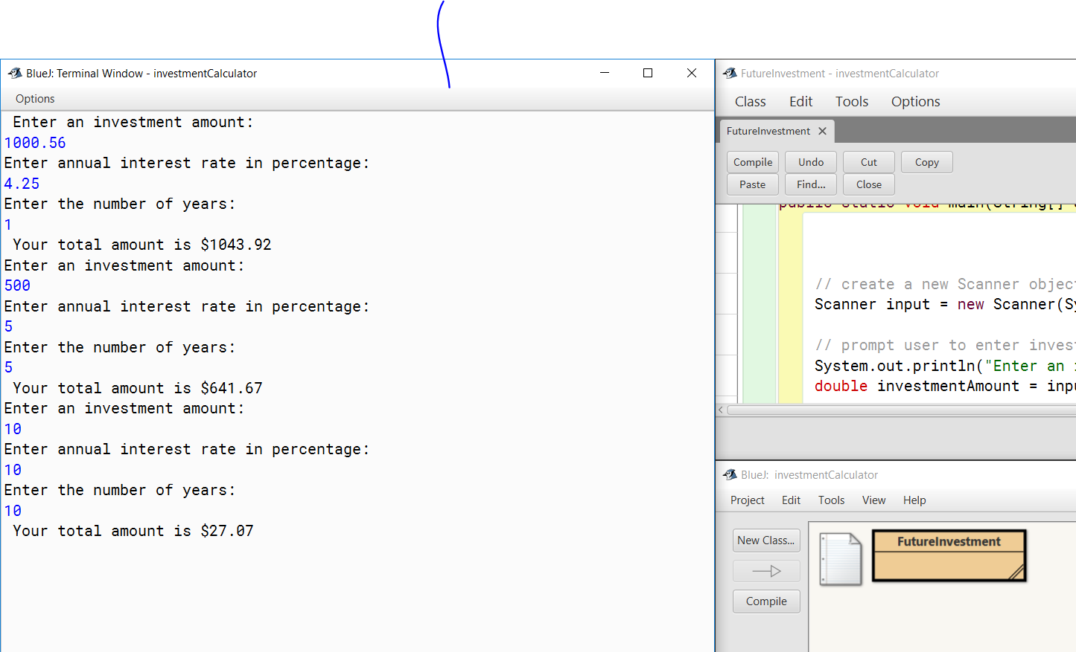**2.21** **Calculate future investment pg. 74 chapter 2**